190905104
Parth Shukla
Lab 5

Study of Domain Name Server & Study of DHCP Server

1)
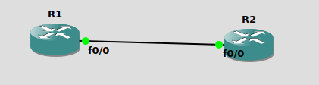

Network details:
DNS Client – R1
DNS Server – R2
R1 – f0/0 – 10.10.10.1/24
R2 – f0/0 – 10.10.10.2/24
R2 – Loopback – 2.2.2.2 loopback.R2.com

Setting up R1:
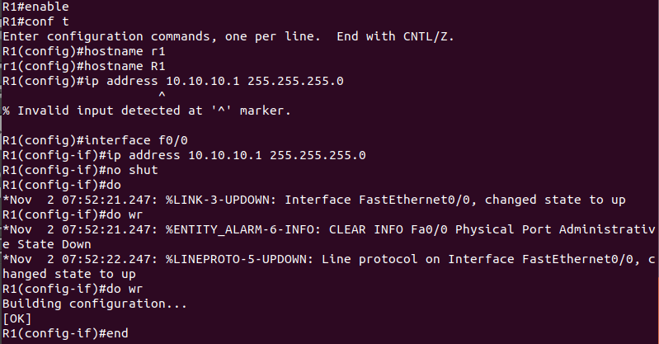
Setting up R2:

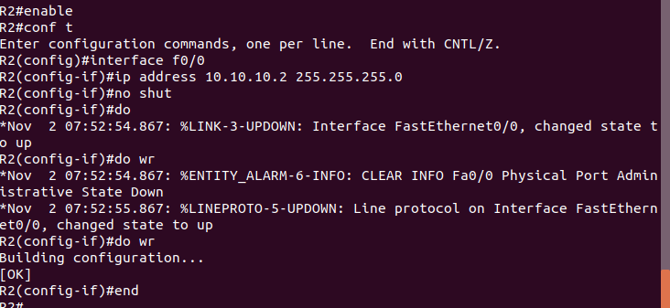
Setting up DNS server to translate loopback.R2.com to 2.2.2.2
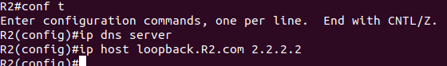

Pinging the address loopback.R2.com from R2 to check if address is translating
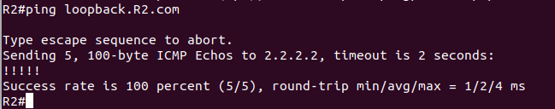
Address is not reachable as R1 is not configured to lookup addresses
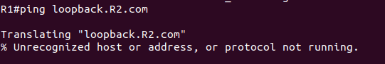
Setup R1 to resolve address on R2
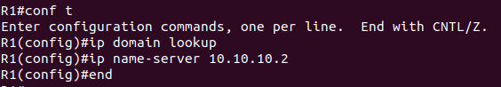

Set up Routing table
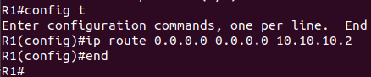

Successful Ping
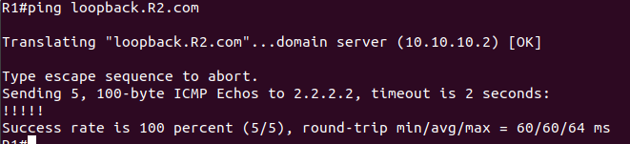
Address resolution
First R1 sends the address to R2 and then R2 returns the IP address to R1.
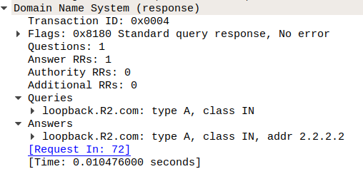

Normal pinging between R1(10.10.10.1) and R2(2.2.2.2):
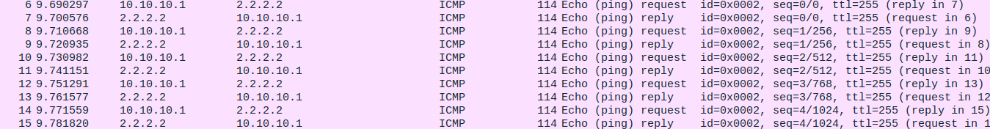

2)
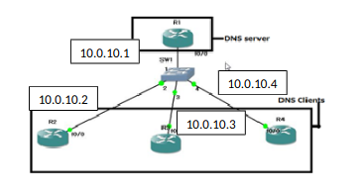

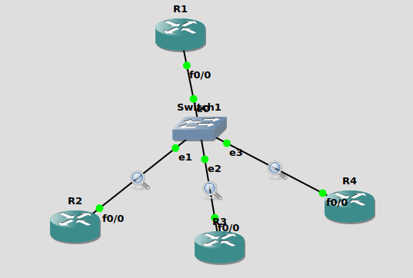
Network details:
R1 – DNS server – f0/0 - 10.0.10.1
R1 – Loopback – 2.2.2.2
R2 – DNS Client - f0/0 – 10.0.10.2
R3 – DNS Client - f0/0 – 10.0.10.3
R4 – DNS Client - f0/0 – 10.0.10.4

Set up R1:
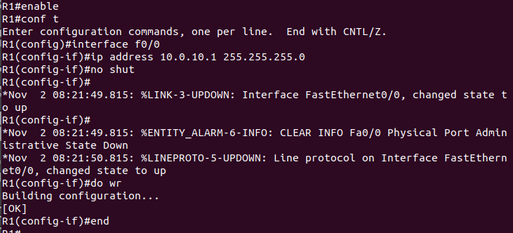

Setting back DNS server and loopback IP address on R1:
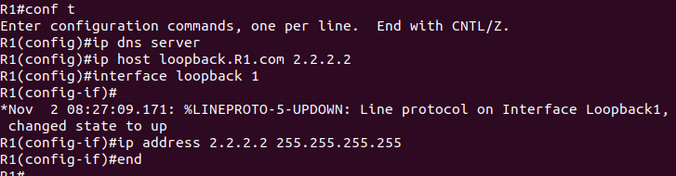
Set up R2 IP address and similarly set up the other routers as well:
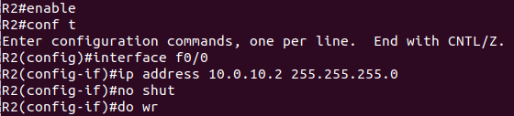
Set up domain lookup address in R2, R3 and R4:

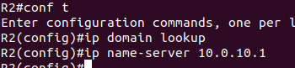

Set up routing table
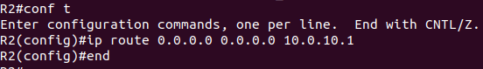

Successful ping and address translation in R1:
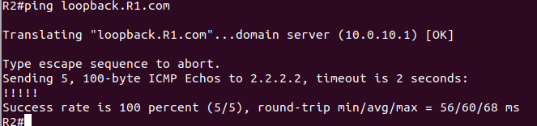
Capture in wireshark for DNS:
As you can see, it returns the address 2.2.2.2 for loopback.R1.com
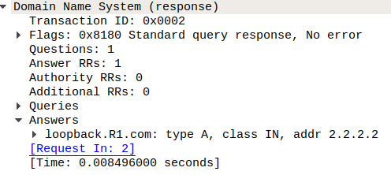

Testing on R3:

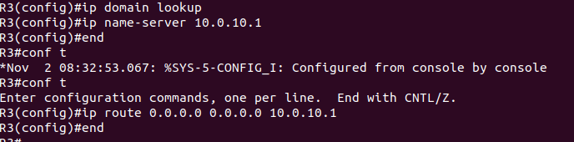
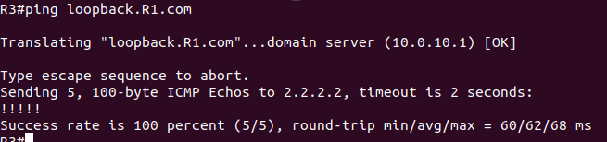
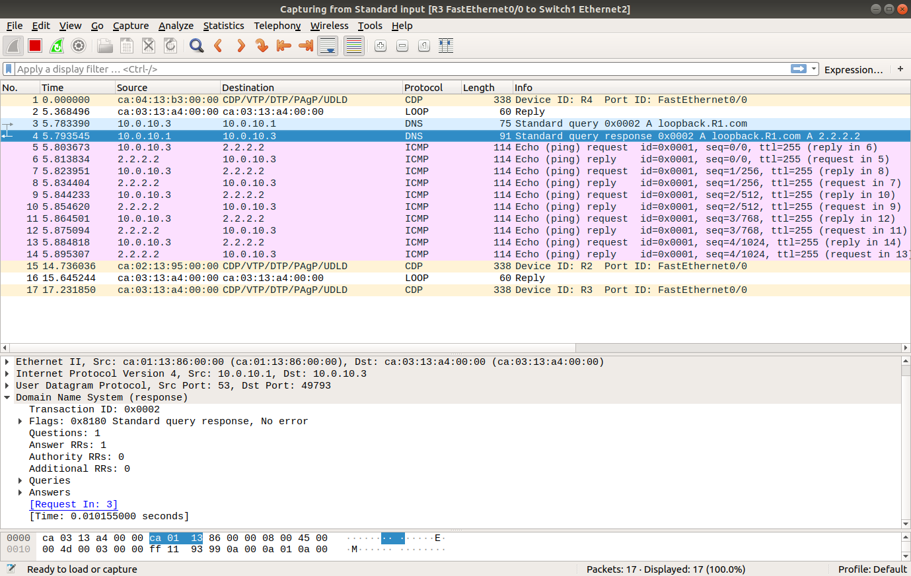
Testing on R4:
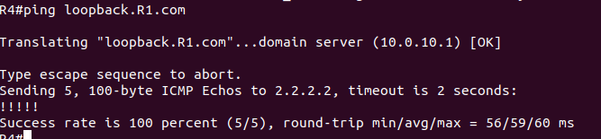
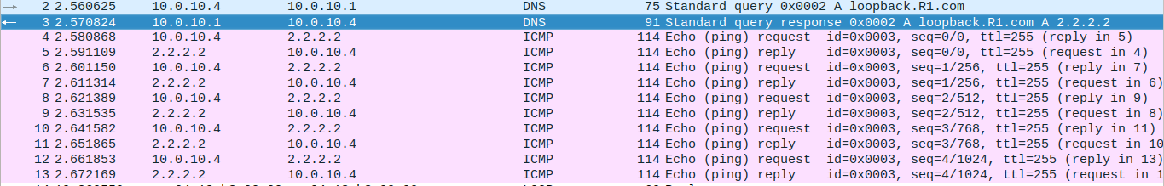

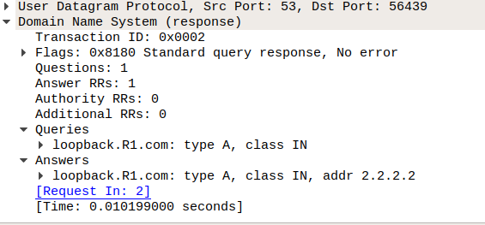
Query and answer clearly visible in this picture

3)

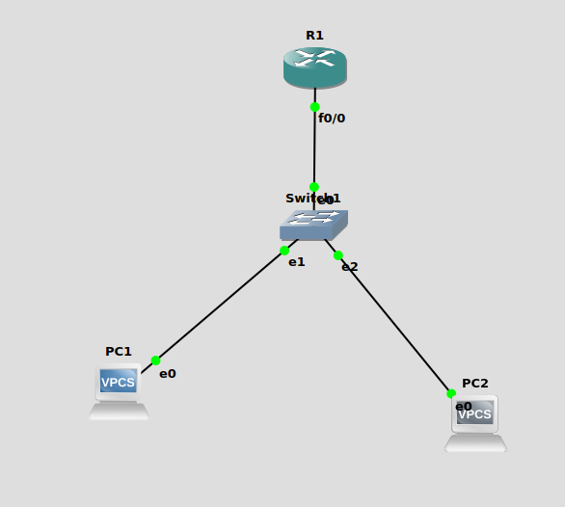
Setting up DHCP
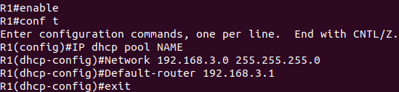
Setting IP address 198.168.3.1 to f0/0
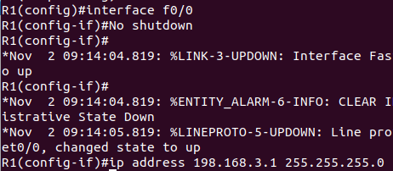

IP address of PC1:
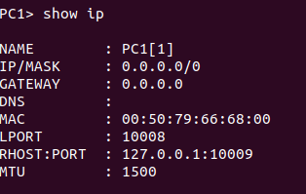

After running dhcp

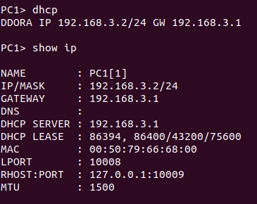

IP adress of PC2
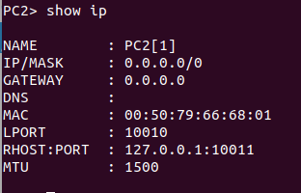

After dhcp

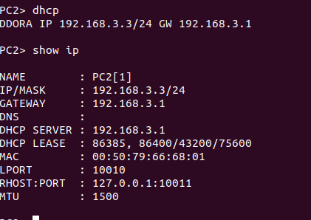

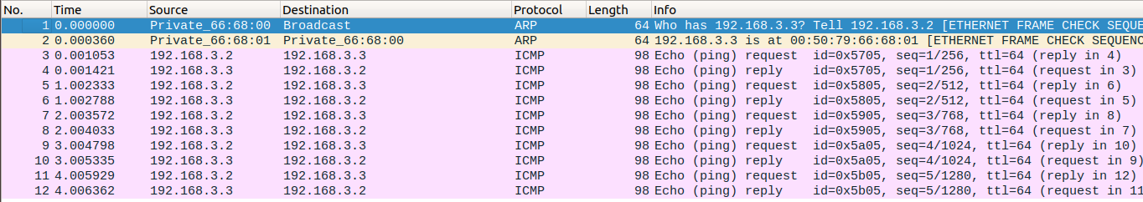
We see a discover message followed by an offer, request, and an acknowledgement.

